Standard Operating Procedure (SOP) under Rebate Item 412.11 for Business importing Critical Supplies

during the National State of Disaster

About this SOP
This Standard Operating Procedure (SOP) acts as a guideline for business importing critical supplies and essential goods into South Africa under Rebate Item 412.11 and Schedule 1(8) of the Value Added Tax Act and includes both imports of dutiable and duty-free goods.
In connection with this document, please note the following definitions:
- ‘critical supplies’ means any product identified in the Covid19-List of Critical Supplies, which document can be found on ITAC’s website (see the following link):
http://www.itac.org.za/upload/Rebate%20Application%20(COVID-19).pdf
- ‘rebate item 412.11’ means the full rebate of custom duties for the critical supplies during the COVID-19 pandemic (currently ITAC will issue rebate certificate with a validity up to 31 May 2020) as contained in Schedule 4 to the Customs and Excise Act 91 of 1964;
- ‘application’ means the application for the importation of critical supplies under rebate item 412.11;
- ‘certificate’ means the official approval by the International Trade Administration Commission of South Africa (ITAC) to import goods under rebate item 412.11, which includes during the pandemic written authorisation provided via email from an ITAC Senior Manager;
- ‘essential goods’ means those goods contained in paragraph A of Annexure B of the Regulations issued on 25 March 2020 in terms of the Disaster Management Act.

Prerequisite: Licensing and Registration

Registered with SARS Customs as an Importer
As per SARS Customs External Policy document SC-CF-55 par 2.1 (a), before importers can make use of rebate item 412.11, they need to be registered with SARS Customs as an importer. Refer to the SARS Customs External Policy document SC-CF-19 for registration requirements.

Registered company with CIPC (Companies and Intellectual Property Commission)
In addition to being registered with SARS, before being able to import goods under rebate item 412.11, a company must be registered in terms of the Companies Act, No 71 of 2008, as well as being registered as an approved operator during the national disaster period.

VAT number (or indicated that the company is not a VAT registered company)
In addition to being registered with SARS and the CIPC, it is mandatory for a business to register for VAT if the total value of taxable supplies made in any consecutive twelve-month period exceeded or is likely to exceed R1 million. The business must complete a VAT 101 - Application for Registration form and submit it to the local SARS branch within 21 days from date of exceeding R 1 million (SARS, 2020).

Refer to HS Code List
A list of critical supplies has been established and means any product identified in the “Covid19 – List of critical supplies” on ITAC’s website. The list consists of goods classifiable under 81 different tariff headings, of which 49 do not attract duty.

Rebate certificate and VAT Exemption
Only dutiable goods as referenced on the “Covid19 – List of critical supplies” are eligible for an ITAC rebate certificate to import these goods under full rebate of the relevant customs duties. For such goods, an application form (which can be found on ITAC’s website) must be completed and submitted to ITAC. The process is described in section B below.
Imports of all goods are exempted from VAT if such goods appear on the list of essential goods and have not been subject to an exclusion. Goods that appear on the list of essential goods but are excluded from (ineligible for) a VAT exemption are (1) goods that are subject to an ordinary customs duty (i.e. duties in Schedule 1 of the Customs and Excise Act) or a trade remedies duty (i.e. duties in Schedule 2 of the Customs and Excise Act) and goods that would ordinarily be subject to the aforementioned duties but are imported duty free under a preferential trade arrangement, as listed in ITAC's VAT certificate referred to below and (2) goods which are currently the subject of an application or investigation by ITAC’s Tariff or Trade Remedies unit which also appear on the list in ITAC's VAT certificate . As a technical matter, such goods are covered by a global certificate issued by ITAC to SARS. ITAC’s VAT certificate also details the above exclusions and can be found at the link-
http://www.itac.org.za/upload/ITAC%20Certificate%20-%20SARS%20Essential%20Goods%20List%20(2)%2020200408.pdf

Application for a Rebate Certificate from ITAC
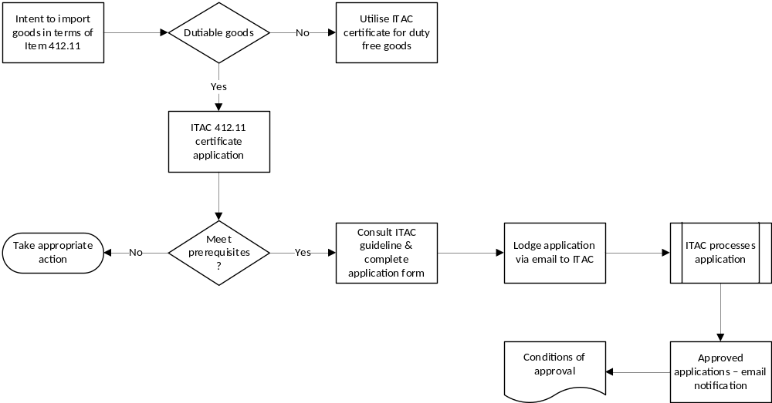

Obtain application form from ITAC website
The application form for rebate item 412.11 can be found on ITAC’s website (ITAC, 2020 and http://www.itac.org.za/pages/about-itac/covid-19-news-and-regulat).

Guidelines for rebate item 412.11
ITAC has published Guidelines that should be read prior to completing the application form. This document is also available on ITAC’s website (see the link in B.1. above). Please note that the Guidelines and the application form are contained in the same document (the application form is Annexure A of the Guidelines).

Application form to be completed
In summary, the following sections need to be completed:
- 1. Details of Applicant;
- 2. Details of Manufacturer (if different from paragraph 1);
- 3. Furnishing of information in respect of each product to be imported;
- 4. Proving details of the nature of the business of the applicant;
- 5. Indicating employment figures in relation to the end- product to be manufactured;
- Sworn affidavit; and
- Check list.
Please note that in completing the application form a common problem is -
- The statistical unit is not provided or is provided incorrectly. Use the statistical unit indicated in the tariff subheading in the Customs Schedule for the good at issue (more often than not kgs).
- Indicate the quantity required for clearance up to 31 May 2020 (by this date imports must be cleared to make use of the certificate). However, the quantity and value applied for must be supported by orders to importers or otherwise substantiated.

Submission of the application via email to ITAC
Applications for a rebate certificate must be submitted electronically to the following officials:
For goods classifiable under Chapter 1 to 68:
- Mr Christopher Sako at csako@itac.org.za; and
- Ms Khosi Mzinjana at kmzinjana@itac.org.za;
For goods classifiable under Chapter 69 to 96:
- Ms Lufuno Maliaga at lmaliaga@itac.org.za

ITAC will process applications expeditiously
Although being a manual process, ITAC will nevertheless endeavour to process the application within three to five days of being submitted. However, ITAC - like all entities currently in South Africa - is also affected by the lockdown. Nonetheless, ITAC is committed to expediting applications. Therefore, all applicants are urged to assist with expediting the process by submitting clearing and supporting documents at the earliest opportunity possible.

Email Notification of Approval to Applicants
The applicant will be advised by ITAC of the outcome. Upon approval of the application, the applicant will be notified by email. Simultaneously, ITAC will email SARS to notify it of the approval (see C.1 below). ITAC will not be issuing physical rebate certificates during the lockdown but only an email approval notification.
The typical content of the email approval notification (rebate certificate) will be:
- Issued to
- Importer’s code
- Certificate number
- Rebate item
- Year of issue
- Address
- Indication that certificate is non-transferable
- Line item – description of commodity
- List of goods
- Tariff subheading
- Quantity
- Customs value
- Validity period
- Conditions

Notification

ITAC notification to SARS
ITAC will communicate its approval to SARS - Customs via e-mail.

Conditions of the Rebate Certificate
The rebate certificate issue by ITAC is strictly subject to the following conditions, which will also appear on the email approval notification:
- This rebate provision is only applicable for COVID-19 relief purposes and for COVID-19 approved critical supplies, which do not include used or second-hand goods.
- The permit is non-transferable.
- For direct importation only and not to be cleared into Bond.
- Goods imported under this rebate item 412.11/00.00/01.00 shall not be sold or disposed of to any party who is not entitled to any privileges under the rebate item, or removed to the area of Botswana, Lesotho, Swaziland or Namibia without the permission of the International Trade Administration Commission.
- Goods imported under this rebate will be subject to monitoring and if a prima facie case is established that any condition of this permit is not complied with, the consignment in terms of which the rebate permit was used can be seized and the rebate permit will be temporarily suspended while SARS and ITAC conduct an investigation. If it is established that non-compliance took place, appropriate steps will be taken. These steps will be taken in terms of the International Trade Administration Act, 2002 (Act No. 71 of 2002) and the Customs and Excise Act, 1964 (Act No. 91 of 1964), and can include, criminal charges, withdrawal of the permit or permits concerned and/or the rejection of future applications for permits.
- All approvals will only be valid until 31 May 2020.

Customs declaration
The information in this and the following sections has been provided to ITAC by Business Unity South Africa (BUSA) and is provided here to further assist with the importation of critical supplies.
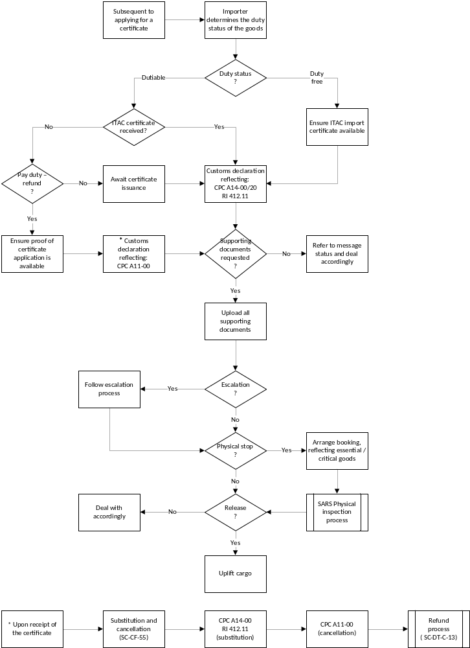

The Import Customs Declaration will reflect the Rebate Item 412.11
The conditions (as outlined per the conditions reflected in the document titled ‘Industry request to fully rebate duty on essential imports during COVID-19 pandemic’) should then be for clearances under CPC A 14-00/20 with measure 412.11/00.00/01.00:
- CPC – Box 1 = A
- CPC – Box 37 = “14” as the requested procedure code and then depending on the previous declaration if any “00” or “20”
- Box 44 = Procedure measure
In the event that the critical supplies arrive in South Africa prior to ITAC issuing the certificate, the importer may opt to pay the duty and VAT, i.e. a normal home use declaration (A 11-00). Once the certificate is issued a refund process can be applied for, which will entail that the home use declaration A 11-00 be substituted with an A 14-00 declaration with measure 412.11/00.00/01.00. The original A 11-00 declaration will have to be cancelled which will effectively start the refund process – the substitution process has strict rules that need to be complied with. More information, available on the SARS website, is contained in the:
- Clearance Declaration External Policy – SC-CF-55 and
- Refunds and Drawbacks External Policy – SC-DT-C-13
It must be noted that the refund procedure will only be applicable in instances where application to ITAC was lodged before clearances of the critical supplies took place.
Importers awaiting the issuance of their certificates are not compelled to pay the duty and VAT and claim it back afterwards, they may elect to wait for the certificate while the critical supplies remain at the temporary storage facility. It must be noted that storage costs may accumulate, it is therefore advisable to consider the available options.

Request of Supporting Documentation (CUSDEC Code 13)
SARS – Customs may request the supporting documentation (including the certificate), for uploading into SARS – Service Manager. All declarants must ensure that they are in possession of all supporting documents prior to lodgement of the declaration. The supporting documents must be uploaded expeditiously after receiving the EDI notification request for documents in order to ensure timely treatment of all declarations.
Comment: Importers must retain their ITAC certificate in the event of a risk-based query from Customs. This would come in the form of Customs ‘Status 13’ –
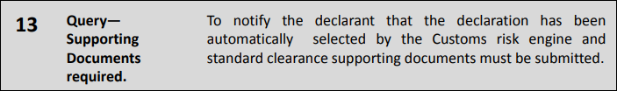
The ITAC rebate item email approval notification and the ITAC VAT certificate (a link which has been provided above) must accompany the supporting document.

Escalation
SARS Customs will monitor the Import Customs declarations for COVID-19 essential supplies, while SARS Branch Call Centre will handle the escalation. A dedicated escalation contact is being set up. However, for the moment, Covid-19 escalations will most likely go through the listed call centre numbers, which are:
- Local callers: 0800 00 7277
- International callers: +27 11 602 2093
Since the vast majority of critical supplies will most likely be air cargo, the contact details of OR Tambo Customs is essential:
OR Tambo International Airport
Contact type: Customs: Airports
Country: South Africa
Region: Gauteng
City: Johannesburg
Building: New Agents Building
Telephone number: 0800 00 7277 or (011) 701 3989/3985/3996
Fax number: (011) 923 2467
Physical address: New Agents Building
Jones Road
Cargo Division

Physical inspection
In the event that the import consignment is stopped for a physical inspection the branch office needs to be contacted to arrange for a booking for an inspection. Should it not be possible to make an inspection booking or if the inspection results are not finalised the escalation process as in Paragraph E must be followed.

SARS Head Office Monitoring
SARS - Head office will also monitor the situation and will assist with cases that is taking longer than the time outlined in this.
SARS Customs has also set up a command centre to deal with escalations that may have not been dealt with at branch level. Your existing call reference number, transaction (SSM/LRN) can then be sent to osc@sars.gov.za. To save duplication and time, clients are reminded that queries must be sent to the relevant branch/processing centre.

Additional SARS information
Refer to the SARS Coronavirus webpage for any updates:
https://www.sars.gov.za/Media/Pages/CoronaVirus.aspx and
https://www.sars.gov.za/ClientSegments/Customs-Excise/Pages/default.aspx

